ID : devans
Starting Records 9754
Processed 6513
Exceptions 3513
Time 00:00:47
Compiles Correctly | 5 | 5
Design of the Problem Solution | 15 | 13
Code Modularisation | 10 | 10
Appropriate commenting and documentation | 5 | 3
Variable Naming (self documenting) | 10 | 7
Appropriate exception handling | 10 | 8
Is the code tight and concise | 20 | 14
Is the code easily maintainable | 5 | 4
Is it easy to run | 5 | 5
Run against the full data, how did the code perform | 10 | 6
Professional Presentation | 5 | 5
TOTAL | 100 | 80

10601514

David.Evans-1@student.uts.edu.au

97069828594915E8

Comments
Record count is too high
Not a bad effort with your design. I’m a little lost with your codes but it looks good

You gave me the tables as an ER Diagram. Let me ask…Did you use the DBP_POSTCODE table? If so why is that not in the diagram?

Consider a title page in your document, Table of contents etc

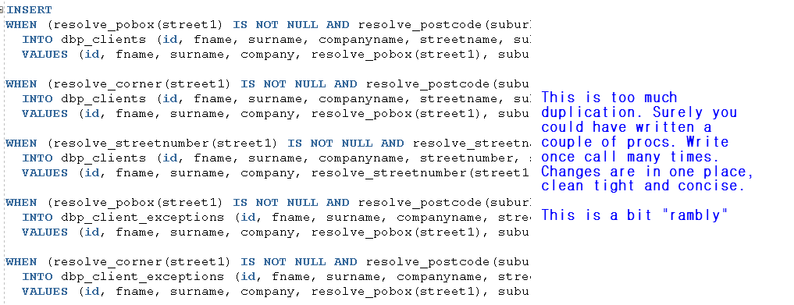

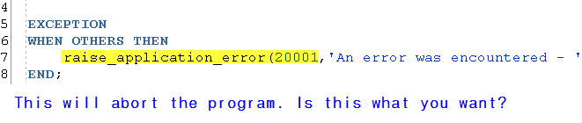

Found only two comments in the whole application.
Each module should have at least details of what it does and who the author is.

